TEACH A CLASS, TAKE A CLASS FOR FREE
www.excotc.org | excotc@gmail.com

TEACH A CLASS, TAKE A CLASS FOR FREE
www.excotc.org | excotc@gmail.com

TEACH A CLASS, TAKE A CLASS FOR FREE
www.excotc.org | excotc@gmail.com

TEACH A CLASS, TAKE A CLASS FOR FREE
www.excotc.org | excotc@gmail.com

TEACH A CLASS, TAKE A CLASS FOR FREE
www.excotc.org | excotc@gmail.com

TEACH A CLASS, TAKE A CLASS FOR FREE
www.excotc.org | excotc@gmail.com

TEACH A CLASS, TAKE A CLASS FOR FREE
www.excotc.org | excotc@gmail.com

TEACH A CLASS, TAKE A CLASS FOR FREE
www.excotc.org | excotc@gmail.com

TEACH A CLASS, TAKE A CLASS FOR FREE
www.excotc.org | excotc@gmail.com

TEACH A CLASS, TAKE A CLASS FOR FREE
www.excotc.org | excotc@gmail.com

TEACH A CLASS, TAKE A CLASS FOR FREE
www.excotc.org | excotc@gmail.com

SUMMER REGISTRATION
NOW OPEN

Register on-line at
>>>www.excotc.org<<<

Classes start the week of June 15th
FREE CLASSES

Experimental
College
of the Twin Cities

Where everyone can teach or take a class
and all classes are FREE
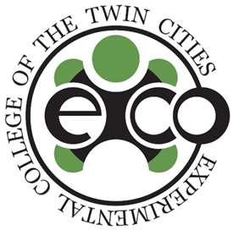

What is EXCO?
EXCO is a collective of Experimental Colleges offering free and open classes.

EXCO offers Twin Cities communities the opportunities to learn or teach in a space open to all kinds of knowledge, including and beyond academic knowledge.

Get involved and learn more: excotc@gmail.com/651.696.8010.

